WORKSHEET : 5

NAME :SAI DINESH B

ROLL NO:20PW30

1.using canvas tag

<html>

<canvas id="myCanvas" width="600" height="400" border="1px">

</canvas>

    <script>

    var c = document.getElementById("myCanvas");

    var ctx = c.getContext("2d");

    ctx.fillStyle = "#fc6b03";

    ctx.fillRect(0, 0, 300,50);

    ctx.fillStyle="white";

    ctx.fillRect(0,50,300,50);

    ctx.strokeStyle="#000080";

    ctx.beginPath();

    ctx.arc(150, 75, 25, 0, 2 \* Math.PI);

    ctx.stroke();

    ctx.fillStyle="green";

    ctx.fillRect(0,100,300,50);

    </script>

</html>

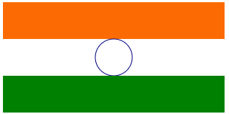

<html>

<canvas id="myCanvas">

    Your browser does not support the canvas tag.

    </canvas>

    <script>

    var c = document.getElementById("myCanvas");

    var ctx = c.getContext("2d");

    ctx.fillStyle = "red";

    ctx.fillRect(20, 20, 75, 50);

    //Turn transparency on

    ctx.globalAlpha = 0.2;

    ctx.fillStyle = "blue";

    ctx.fillRect(50, 50, 75, 50);

    ctx.fillStyle = "green";

    ctx.fillRect(80, 80, 75, 50);

    </script>

</html>



2.using mark tag:

<html>

    <h1><mark>Captain Vikram Batra</mark> (9 September 1974 – 7 July 1999), <mark>PVC</mark>, was an officer of the Indian Army. He was posthumously awarded the <mark>Param Vir Chakra</mark>, the highest military decoration of the Republic of <mark>India</mark>, for his actions during the <mark>1999 Kargil War</mark>, where he led one of the most difficult mountain warfare operations in Indian military history; <mark>Batra</mark> was killed in action by the fleeing <mark>Pakistani troops</mark> around Area Ledge, <mark>Point 4875 in Kargil</mark>, erstwhile Jammu and Kashmir on 7 July, during the three-month-long conflict.</h1>

</html>

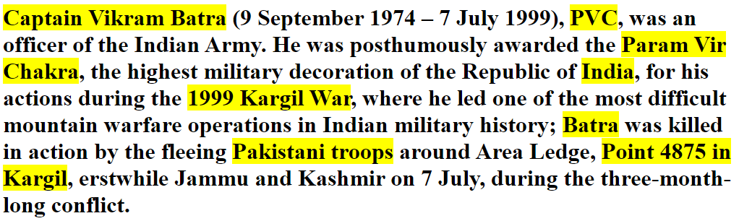

4.

<html>

    <form>

        <label for="name">Search Box</label>

        <input type="text" name="name"></input><br><br>

        <input type="date" name="name"></input><br><br>

        <input type="time" name="name"></input></br><br>

        <input type="submit" value="submit"></input>

    </form>

</html>

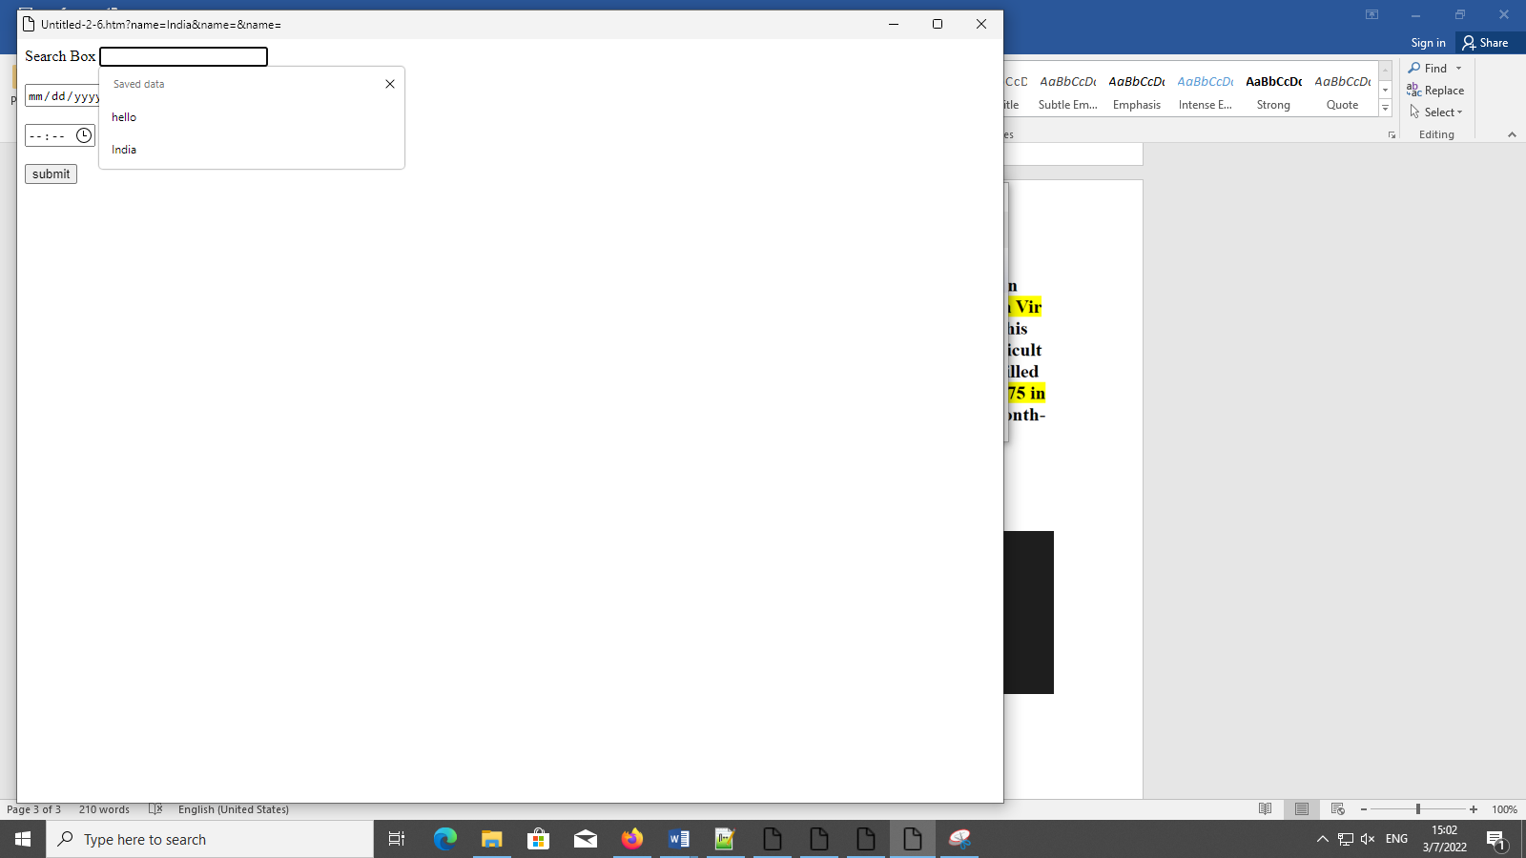

5.DATE PICKER

html>

    <body>

        <center>

            <label  for="date">Date</label>

            <input  type="date" value="2018-07-22" min="2018-01-01" max="2018-12-30">

        </center>

    </body>

</html>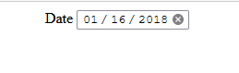

6.iframe tag

<html>

    <body>

        <center>

        <table border=”1”>

            <tr>

                <td>

                    <a href="https://www.psgtech.edu/" target="ifr"><button>PSG CT</button></a><br>

                    <a href="https://www.kct.ac.in/" target="ifr"><button style="width:55px;">KCT </button></a><br>

                    <a href="https://www.srec.ac.in/" target="ifr"><button style="width:55px;">SREC</button></a>

                </td>

                <td>

                    <iframe src="https://www.psgtech.edu/" name="ifr" width="400px" height="400px" </iframe>

                </td>

            </tr>

        </table>

        </center>

    </body>

</html>

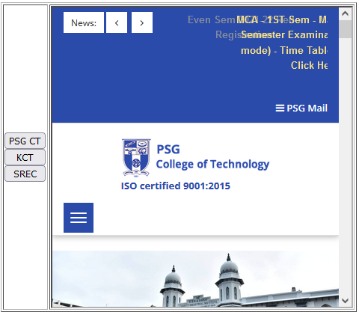

7.

<html>

    <body>

        <table border="1">

            <tr>

                <td>Circle</td>

                <td>

                    <svg width="100" height="100">

                        <circle cx="50" cy="50" r="40" stroke="green" stroke-width="4" fill="yellow" />

                    </svg>

                </td>

            <tr>

            <tr>

            <td>Rectangle</td>

                <td>

                    <svg width="400" height="100">

                        <rect width="400" height="100" style="fill:rgb(0,0,255);stroke-width:10;stroke:rgb(0,0,0)" />

                    </svg>

                </td>

            <tr>

            <td>Rounded rectangle</td>

                <td>

                    <svg width="400" height="180">

                        <rect x="50" y="20" rx="20" ry="20" width="150" height="150"style="fill:red;stroke:black;stroke-width:5;opacity:0.5" />

                    </svg>

                </td>

            <tr>

</svg>

</html>

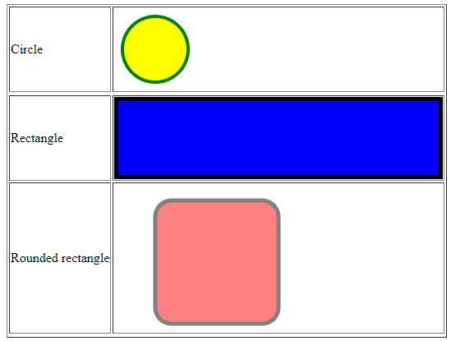

7.AUDIO TAG

<html>

    <p>Jalabula Jangu</p>

    <audio controls>

        <source src="Jalabulajangu-MassTamilan.mp3.mp3" type="audio/mp3">

    </audio>

</html>

